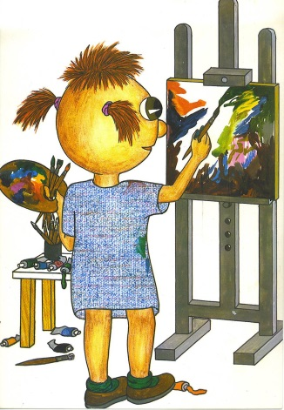 Linqua ART.eu / ART.uk / ART.ru / ART.de

„( …) Wszelka komunikacja międzyludzka jest komunikacją między kulturami. Język jest najważniejszym elementem kultury i w nim kultura najpełniej się wyraża.”
Communicating means understaning people and cultures. Language is the most important element of any culture and nothing can express culture better than language.
prof. Waldemar Pfeiffer

International contest LinquaART.eu entitled:
„ Painted by words.”

Organizer :
- Silesian Branch of the Poland –East Partnership Association in Katowice
- Secondary School nr 1 in Wodzisław Śląski
- High School im. Noblistow Polskich in Rydultowy
- Primary school Mikolaja Reja in Gorzyczki
Partners:
- The Institute of Slavonic Languages, University of Silesia ,Poland,
- School of Polish Language and Culture University of Silesia, Poland
- International Institute of Culture „Klic”, The Czech Republic,
- Language School Elis , Neftekamsk, Russia,
- Gymnasium Sofija Loka, Slovenia,
- Georgian-American School, Tbilisi, Georgia,
- Association for Freindship and Cooperation, Biszkek, Kyrgyzstan
Patronage : Dr Jan Olbrycht, Deputy of the European Parliament
Adam Gawęda, Senator RP ,
County executive of the Wodzisławski region,
City mayor , Mieczyslaw Kieca,
Intercultura Foundation AFS, Russia
The Foundation for Polish-German Cooperation

II. The main aim of the contest: to increase students’ motivation for learning foreign languages using literature and art.
Detailed aims:
- incorporating literature and art into learning European culture and languages
- developing students’ imagination and artistic skills
- promoting reading and foreign language learning
- integrating teenagers and developing their creativity
- raising students’ cultural awareness and participation in culture

III. Contest regulations :
- participants: primary, lower-secondary and secondary school students who are learning or speak one of the following languages: English, German, Russian;

- there are two age categories: age 12-15 and 16-19;

- art school students will be considered separately (one age category: 15 – 19)

- students participate individually. Each school can enroll up to three students in a given language category;

- the task: participants are to read a part of literary work (a fable, a legend, a story) of their choice and prepare artwork to illustrate the text. Techniques to be used: any: flat (e.g. drawing, painting, graphics, cut-out, computer graphics, etc.) Format of work: not smaller than A4 and not bigger than A2. Works should not be framed;

- student’s work should be accompanied by: a summary that will show the connection between artwork and the text read (6-8 sentences) in a chosen language. The author and the title of the book should also be provided;

- the artwork and the literary work (summary) should be sent together with the participant’s questionnaire (Attachment 1) – the questionnaire should be completed for each participant separately;

- Students work individually under teacher’s supervision and send their materials electronically (work scan + summary + questionnaire) to the address of the organizer: bogumilasw@gmail.com
the deadline is 28th February 2017.

- an independent Jury will qualify for the finals based on the criteria which include: compliance with the competition slogan, linguistic correctness and substantive summary in a foreign language, originality and the idea of presenting the content of the reading as well as aesthetic and artistic value of artwork;

- participants will be informed by e mail or phone call about their results and about conditions concerning their participation in the final; the results will also be presented on the website : www.skalna1.edu.pl , zs1@wodzislaw-slaski.pl
- the final Ceremony will take place on 31 th March 2017

IV. Prizes :
- winners and their teachers will be awarded a trip to London, Scotland, Brussels, Moscow or ST. Petersburg (20 trips; they will also receive diplomas and valuable prizes;
- all participants will be awarded with diplomas and teachers will receive congratulatory letters ,
V. General comments:
- please notice the deadline which is obligatory for all participants, any work sent after the deadline will not be considered;
- works sent to the Contest will not be returned
- the organized keeps the right to present artwork during exhibitions, in material promoting the Contests as well as in articles published both in Poland and abroad;
- by sending their work authors declare their copyrights to this work;

- Contest participants accept the regulations and they agree to processing their personal data, making their work public, disseminating their presentations and publishing photos from the Final Ceremony in both polish media and abroad;
- any work that does not meet the requirement will not be taken into account;
- about matters not included in the regulations decide organizers;
- organizers provide a lot of publicity and press service;
VI. For more information contact :
Bogumila Rozanska-Swierkot tel. + 48 693 44 59 55 e-mail: bogumilasw@gmail.com

